Instructions for Session 3 Mapping Process

Go to: http://www.aic-3.com/maps.php Click on Leadership Maps to arrive below:

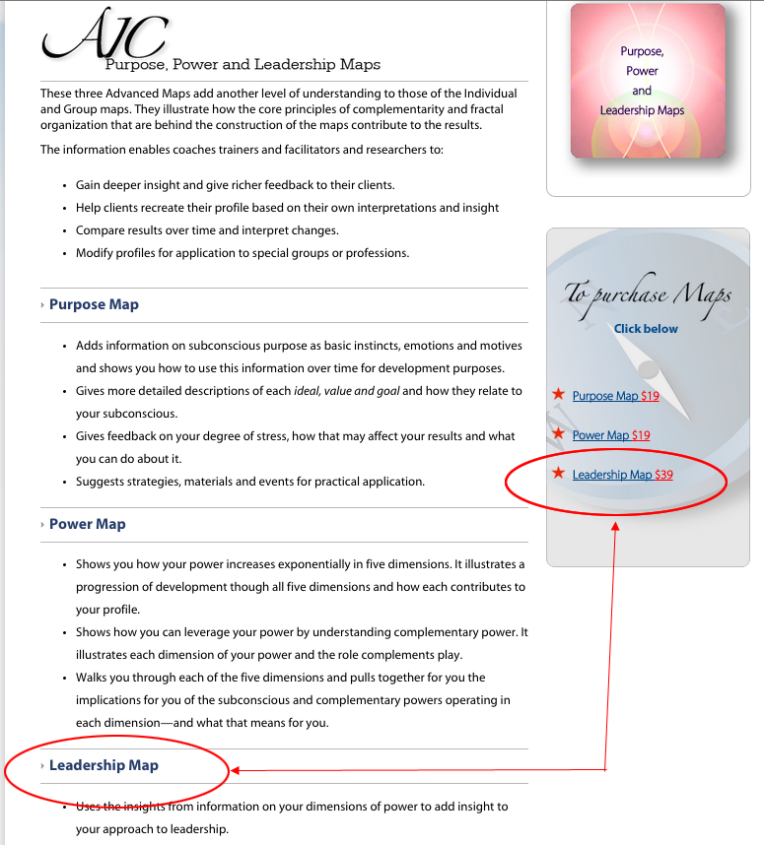
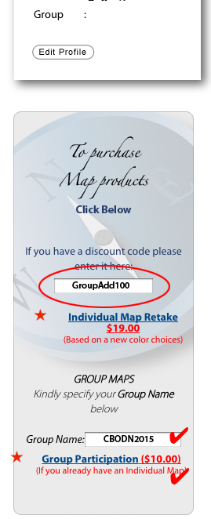
To add yourself to the Group Map:

Go to: http://www.aic-3.com Login at top of page to arrive on Member Page (left):

Enter Group Discount GroupAdd100

Enter Group Name CBODN2015

Click on Group Participation

Both a free Group Map and the Leadership Map will be added to your Membership Page.

You can access you Membership Page at any time by using the Login at the top of every page on www.aic-3.com

Bring your laptop, smartphone or a hard copy of your reports to the session. (Hint: print as a pdf for best results)

As a last resort those who arrive 30 min before the session begins will be able, on their own laptops or smartphone, to complete the mapping process.

